3G150B-How to limit the computers to access the internet through MAC address filter?
Product line: 3G Question category: Function configarations

Q：Why we need to set the MAC address Filter?
A：Sometimes we want to limit some computers in the LAN to access the Internet. You can achieve this through MAC Address Filter.
Note: You can set the MAC Address Filter only when the 3G150B is in 3G Router mode or Router mode.
The Topology is as below:
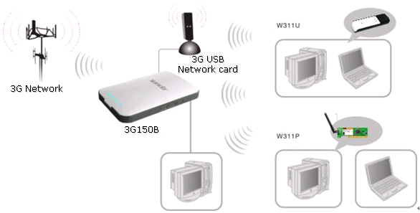
The steps are as below:
1. You should know the MAC address of the computers which you want to limit to access the Internet. You can check them on the computers with command prompt. Click Start→Run. Type cmd and press Enter.
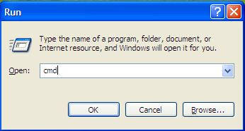
Type ipconfig /all at the prompt window, press Enter, it will show the MAC address and other address information of this computer.
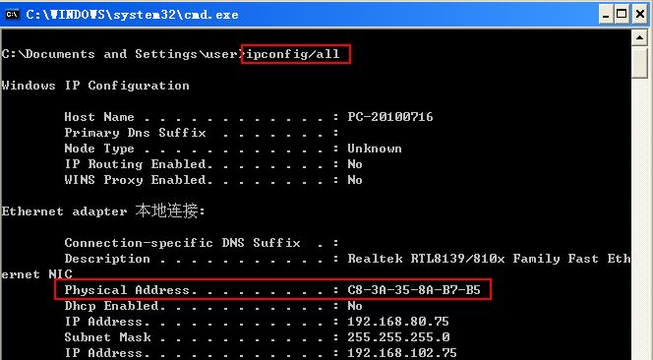
2. Login to the management page of the router.
3. Click Security Settings→MAC Address Filter. The MAC Address Filter is default disabled.
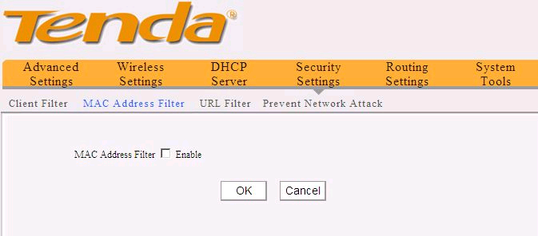 Tick the Enable to enable the MAC Filtering Settings.
For example, we want to limit the computer with the MAC address C8-3A-35-00-EC-E5 to access the Internet from 8:00am to 18:00 pm every day. And the computer with other MAC address can access Internet. You can set the router following the picture as below.
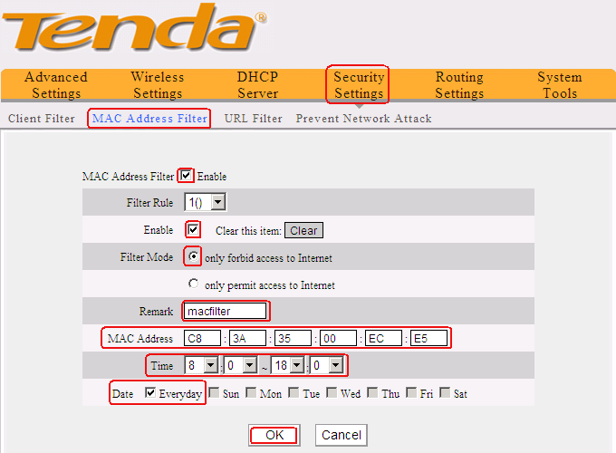
On the contrary，you only want the computers with the MAC address C8-3A-35-00-EC-E5 to access the Internet from 8:00am to 18:00 pm everyday and others can’t access Internet. You can set the router following the picture as below.
